Create an IAM Role for Lambda Execution
Before deploying the Lambda function, create an IAM role with the necessary permissions.
Create an IAM Role:
- Go to AWS IAM Console → Click Roles → Create Role.
- Select "AWS Service" → Choose Lambda.
- Attach the following policies:
  - AWSLambdaBasicExecutionRole
  - AmazonDynamoDBFullAccess
- Name the role (e.g., LambdaExecutionRole) → Click Create role
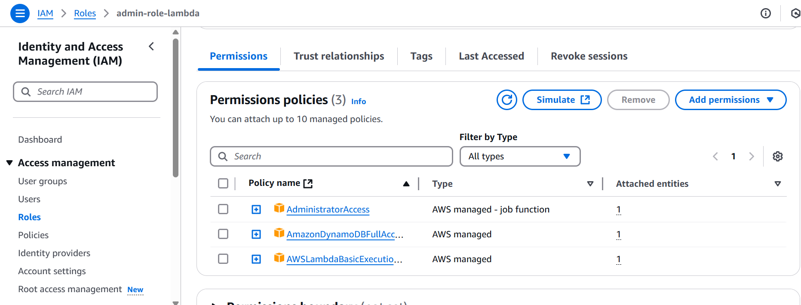
Create a Lambda Function
Steps to Create the Function:
- Go to AWS Lambda Console → Click Create Function.
- Select "Author from scratch".
- Enter a Function Name (e.g., Serverless-App).
- Select a Runtime (e.g., Python 3.9).
- Choose Existing Role → Select LambdaExecutionRole.
- Click Create function.
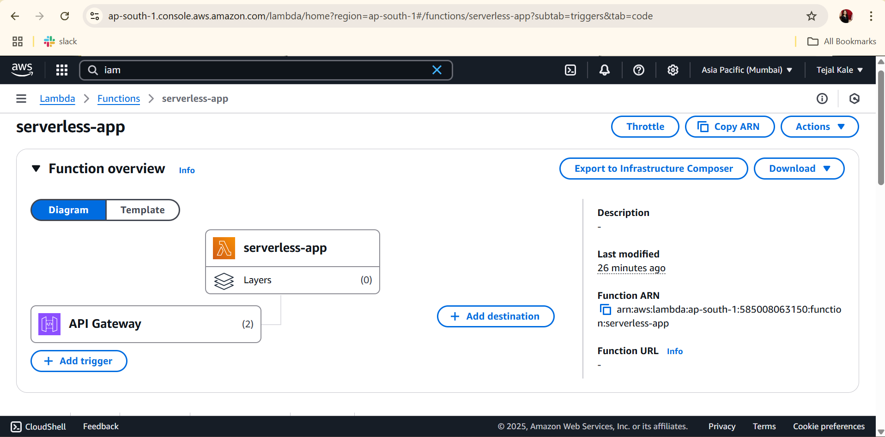

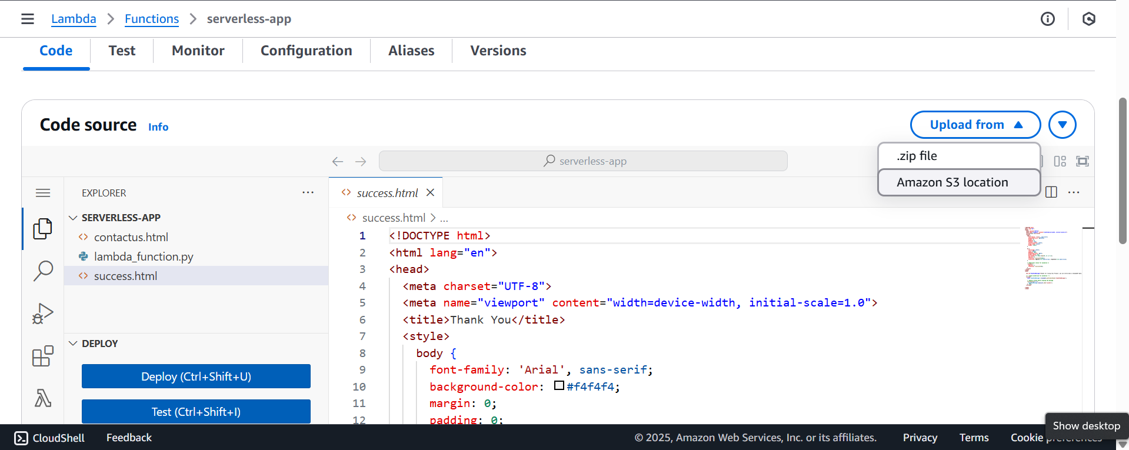
Create the DynamoDB table
We need a DynamoDB table to store the data for our API.
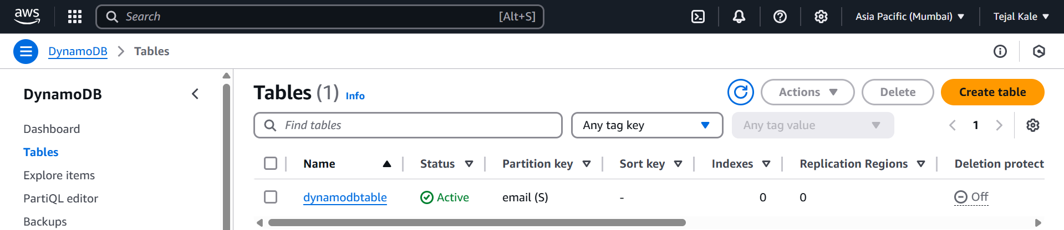

Create an API in API Gateway
Steps to Create API Gateway:
- Go to API Gateway Console → Click Create API.
- Select "REST API" (more control).
- Click Build → Enter an API Name (e.g., MyAPI).
- Click Create API.
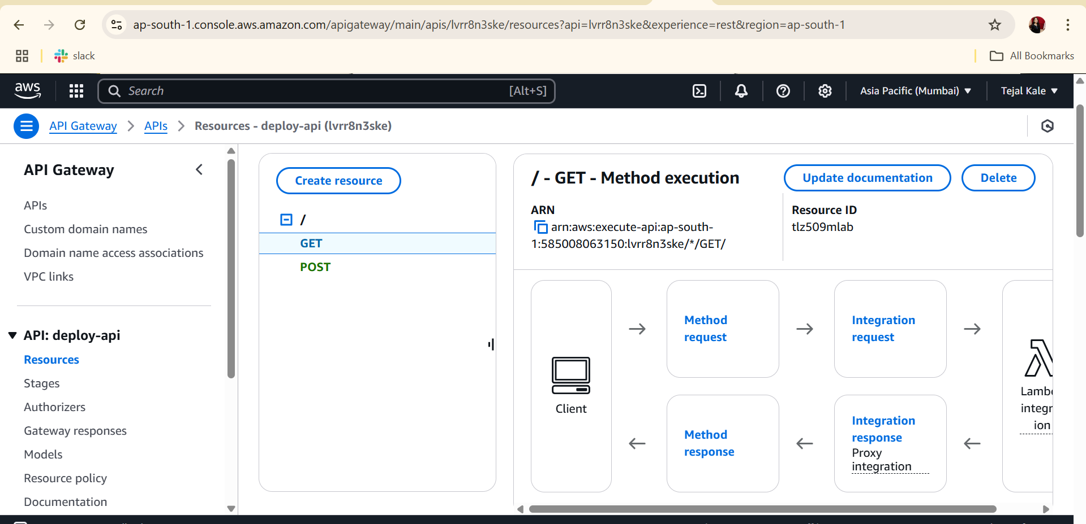

Configure API Gateway Integration with Lambda
Steps to Integrate API with Lambda:
- In API Gateway, go to Routes.
- Click Create Route → Choose GET.
- Enter the Path (e.g., /hello).
- Click Attach Integration → Select Lambda Function.
- Choose your Lambda Function (Serverless-App).
- Click Save.
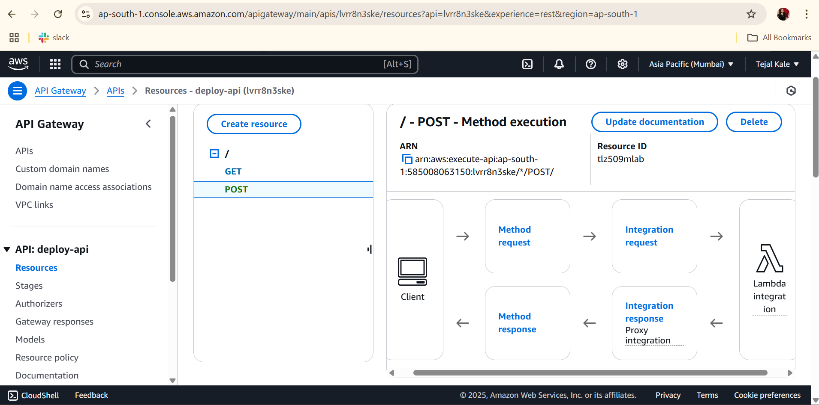
Deploy API and Get the Invoke URL
Steps to Deploy API:
- In API Gateway, go to Deployments.
- Click Create Stage → Name it dev
- Click Deploy.
- Copy the Invoke URL, which looks like: https://lvrr8n3ske.execute-api.ap-south-1.amazonaws.com/dev
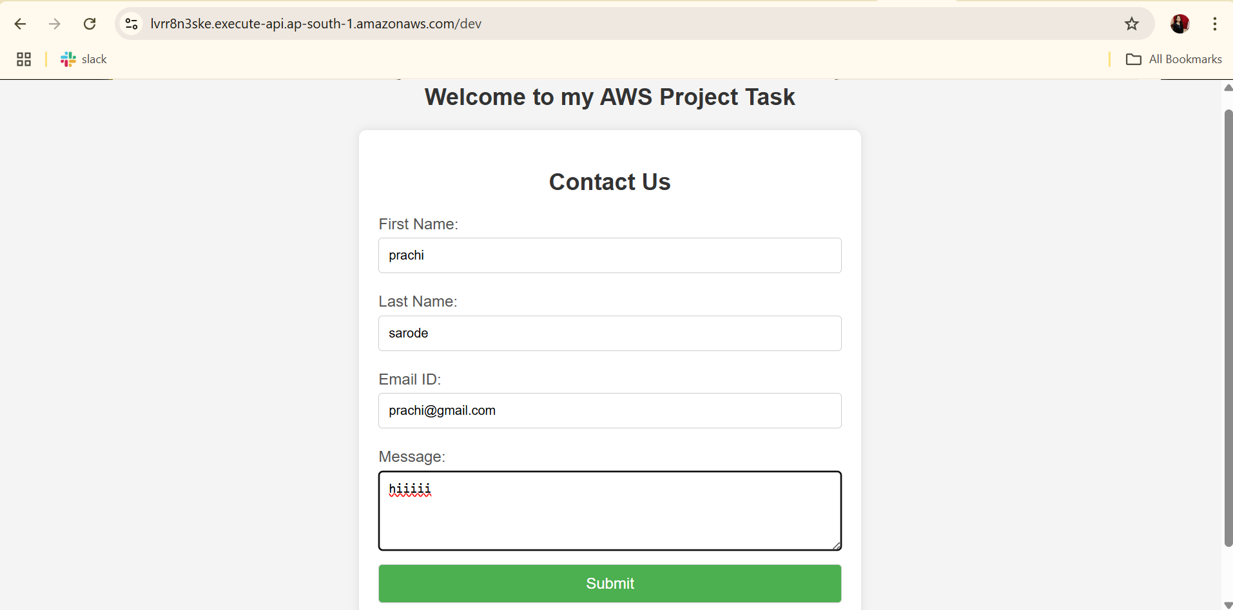

Secure API with an API Key
Create and Use an API Key:
- In API Gateway, go to API Keys → Click Create API Key.
- Enter a Name for the API Key → Click Save.
- Create a Usage Plan → Attach the API Key.
- Associate the API with the Usage Plan.
Test API with API Key Using API Testing :
Enter Invoke url and api-key for testing :
